

FOR IMMEDIATE RELEASE:

NEW YORK (April 29, 2016)

It is with great pleasure that Tucker Robbins announces an exhibition of the work of American Modernist Sam Glankoff (1894-1982). “Our showroom has never looked so beautiful,” proclaims Tucker Robbins. “Having just discovered the work, I immediately gave every available wall to Sam’s paintings. This visual dialogue of hand-hewn elegance is a marriage of both our worlds.”

The exhibition focuses on the later years of Glankoff’s career, when decades of technical and aesthetic experimentation culminated in his innovative “print-paintings,” as they have come to be known. Glankoff’s monumental works are informed by a lifetime of painting and woodcut printing and dictated in construction by the exigencies of Glankoff’s small, New York City apartment on 33rd Street where he lived for fifty years, and which you can see from Tucker Robbins window. With very few exceptions, each work is comprised of at least two panels which Glankoff reverse-painted on plywood boards and transferred onto uniform Japanese mulberry paper panels – a process of layering inks and casein that he repeated up to a dozen times per image, carefully calibrating the paper each time to it’s matrix. Glankoff then assembled the panels to their monumental scale.

Glankoff’s deeply resonant works; their primordial shapes and simplicity of forms, most notably circles, illustrates the commonality between his work and Tucker’s deeply inspired aesthetic.

**www.samglankoff.com**

Along with the original master works, museum quality archival print reproductions of a limited number of images are also available.

**www.samglankoff-sgw.com**. Use code “Tucker” to receive 10% off of the retail price.

***Sam Glankoff: Print Paintings on Paper***Opening Reception

May 12, 2016 | 5pm-7pm

200 Lexington Ave | Suite 504

New York, NY 10016

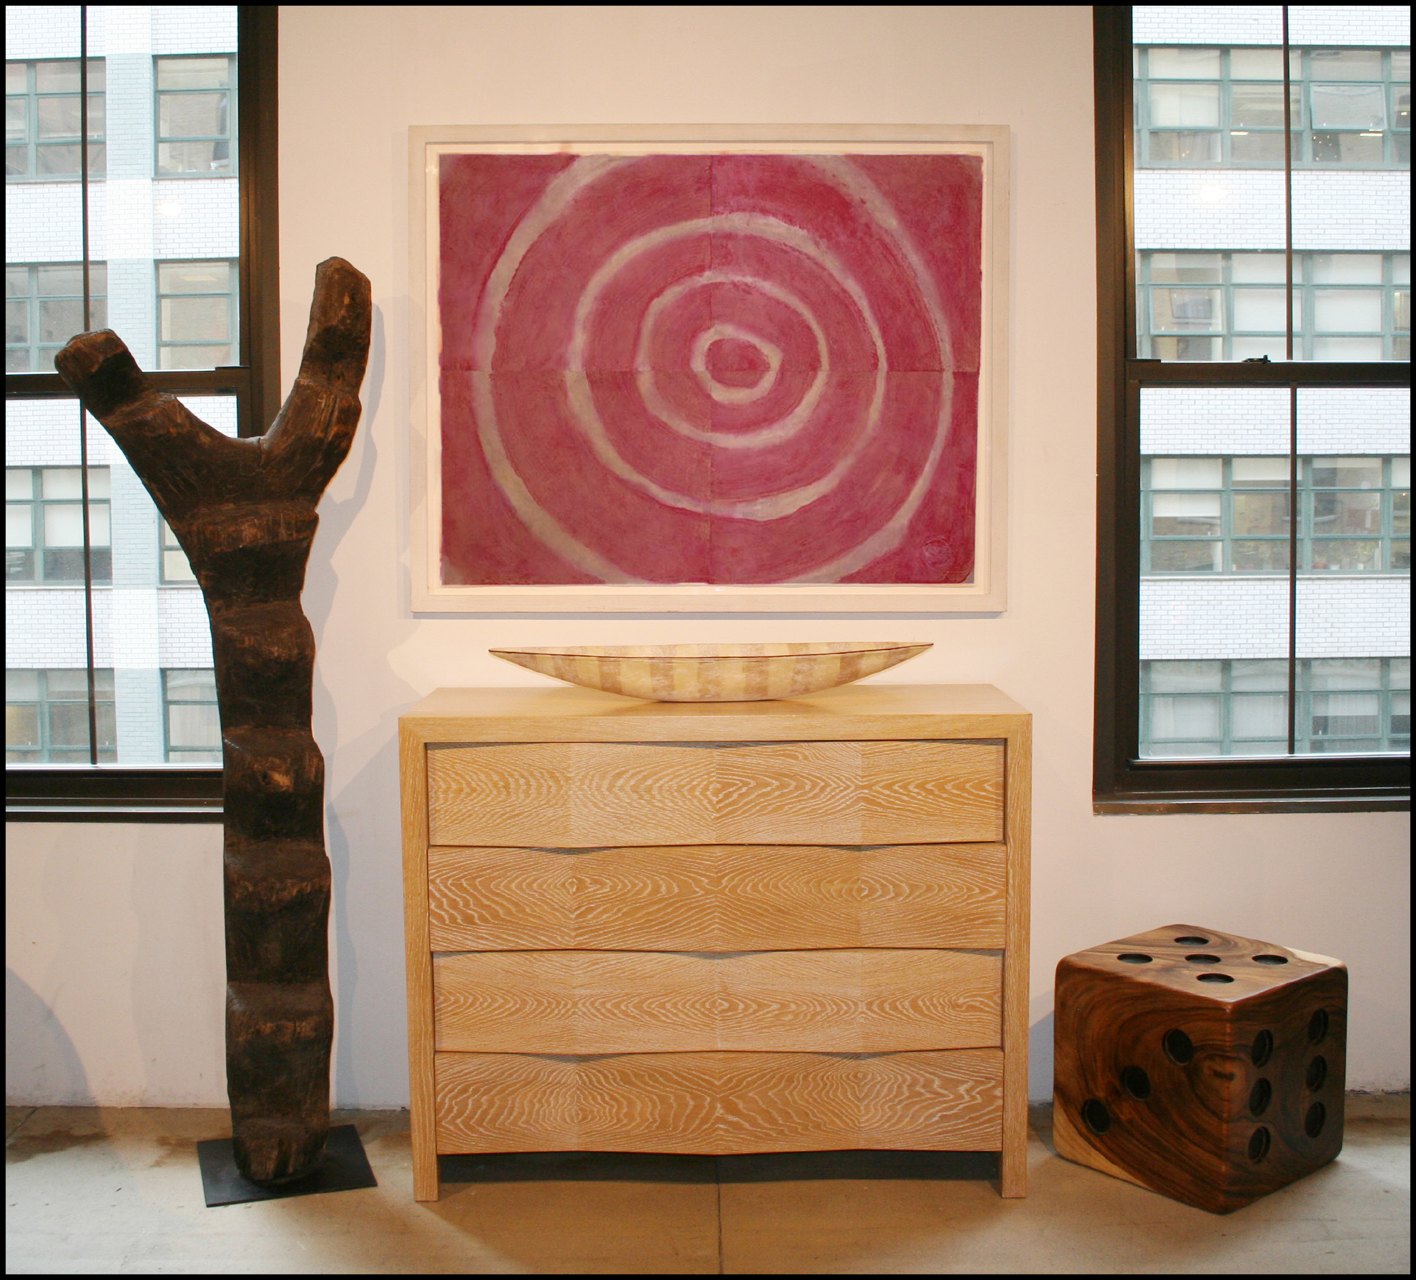

Tucker Robbins has been dedicated to the marriage of great design and authentic tradition for over 30 years. By combining ancient techniques and iconic forms, he creates furniture that is both modern and timeless. His vision has remained steadfast in its focus and simple yet meaningful in its mission: to be a bridge between disparate cultures, be they African, Japanese, American or Tribal. He has created thriving artisan workshops in Guatemala, Honduras, Peru, Philippines, Indonesia, Sri Lanka, and Cameroon, working purposefully with sustainably harvested or reclaimed materials. Respected and renowned for his support of indigenous cultures and traditional handcraft, he has formed partnerships with Tribal Chiefs, Arabian Sheikhs, and village artisans around the world. The result is an extraordinary and unique collection of modern furniture, textiles, and accessories in which each piece is simultaneously a work of art and a reflection of worlds that have come before.

Contact:

Tucker Robbins

212.355.3383

design@tuckerrobbins.com

**www.tuckerrobbins.com**